[Home](https://techposts.org/)

[IoT (Internet Of Things)](https://techposts.org/category/iot-internet-of-things/)

[ESP8266](https://techposts.org/category/iot-internet-of-things/esp8266/)

How to Make DIY IR Blaster using ESP8266 (NodeMCU)

**How to Make DIY IR Blaster using ESP8266 (NodeMCU)**

[Ravi Singh](https://techposts.org/author/checknmater/)  [ESP8266](https://techposts.org/category/iot-internet-of-things/esp8266/), [How To](https://techposts.org/category/how-to/), [IoT (Internet of Things)](https://techposts.org/category/iot-internet-of-things/)  [5 Comments](https://techposts.org/make-diy-ir-blaster-esp8266-nodemcu/#comments)

Recently, I made a **DIY IR blaster using an**[**ESP8266**](https://amzn.to/34PYXun)module, which is available for less than $5 or INR 350. Although I have an [Oakter IR blaster](https://amzn.to/3vUT2QH" \t "_blank) that I purchased from Amazon (for INR 1400) last year, it is too slow to respond to volume or temperature increase or decrease.

However, the Oakter IR blaster works well and can be controlled over the internet and through Alexa and Google Assistant. But the one we are going to build today works within our home network however, it’s much faster and works almost like an actual remote control. Unlike the pre-built IR blasters, such as Oakter, which takes at least 1.5 seconds to respond, there’s is almost no delay with our DIY IR blaster. Plus, it’s cheap and you will get to learn a lot.

Also, you can control the DIY IR blaster from your PC, Laptop, Tablet, or Android phone via a web browser.

**Contents**  [hide](https://techposts.org/make-diy-ir-blaster-esp8266-nodemcu/)

[Steps to Build DIY IR Remote using ESP8266](https://techposts.org/make-diy-ir-blaster-esp8266-nodemcu/#Steps_to_Build_DIY_IR_Remote_using_ESP8266)

[Step 1: Purchases the Required Components](https://techposts.org/make-diy-ir-blaster-esp8266-nodemcu/#Step_1_Purchases_the_Required_Components)

[Step 2: Install and Setup Arduino IDE](https://techposts.org/make-diy-ir-blaster-esp8266-nodemcu/#Step_2_Install_and_Setup_Arduino_IDE)

[Step 3: Capture and Record the IR Codes](https://techposts.org/make-diy-ir-blaster-esp8266-nodemcu/#Step_3_Capture_and_Record_the_IR_Codes)

[Step 3: Build IR Blaster](https://techposts.org/make-diy-ir-blaster-esp8266-nodemcu/#Step_3_Build_IR_Blaster)

[Step 4: Setup Remote Control Shortcuts](https://techposts.org/make-diy-ir-blaster-esp8266-nodemcu/#Step_4_Setup_Remote_Control_Shortcuts)

[Step 5: Control Your IR Devices](https://techposts.org/make-diy-ir-blaster-esp8266-nodemcu/#Step_5_Control_Your_IR_Devices)

[What's Your Reaction?](https://techposts.org/make-diy-ir-blaster-esp8266-nodemcu/#Whats_Your_Reaction)

STEPS TO BUILD DIY IR REMOTE USING ESP8266

Below we have explained the process to build a universal IR remote controller using Arduino, ESP8266, IR LED, and IR Receiver sensor. This guide is divided into 5 steps where we will capture the IR codes from your IR remotes and then build the IR blaster using those codes to control any IR devices, such as TV, Home Theater, LED lights, etc.

We have also uploaded a video guide that you can watch here (coming soon).

STEP 1: PURCHASES THE REQUIRED COMPONENTS

* [ESP8266 Module](https://amzn.to/3vRjdHU) (INR 350)
* [IR LED](https://amzn.to/3psfJtc) (INR 10-20 from local store or online)
* A [2N2222](https://amzn.to/3uVvLN2) or [B547 Transistor](https://amzn.to/3g9vbpL) (INR 10)
* A [IR Sensor](https://amzn.to/2T2uvL3), such as [TSOP1738](https://amzn.to/3z093qB) (INR 20-50)
* A [WiFi router](https://amzn.to/3wYTcGH" \t "_blank)(does not require internet, just any router)

***TIP:****You can buy these items at a much cheaper price from a local or online electronic store, such as Roboelements.com.*

This DIY IR blaster is at least 3 times cheaper. Thus, you can build more and install them in each room.

STEP 2: INSTALL AND SETUP ARDUINO IDE

[Download Arduino IDE](https://www.arduino.cc/en/software) for your Windows, Linux, or macOS and install it. Also, download and[install the ESP8266 drivers](https://sparks.gogo.co.nz/ch340.html). Then open Arduino IDE and follow these steps.

* Connect the Nodemcu (ESP8266 Module) via micro USB cable and then open **Arduino IDE**.
* Navigate to **File>Preferences** and paste the following URL in the ‘**Additional Boards Manager URLs**‘ box.

**http://arduino.esp8266.com/stable/package\_esp8266com\_index.json**

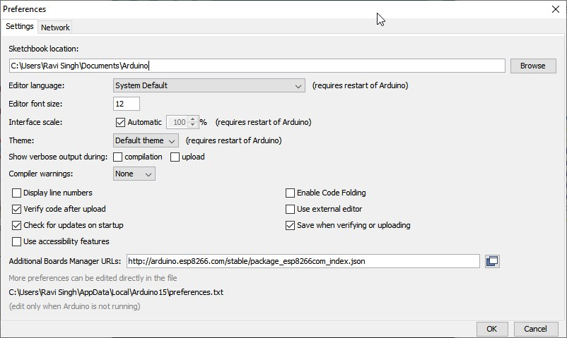

* Click ‘**OK**‘ and then go to “**Tools>Board**” and select “**Boards Manager**.”

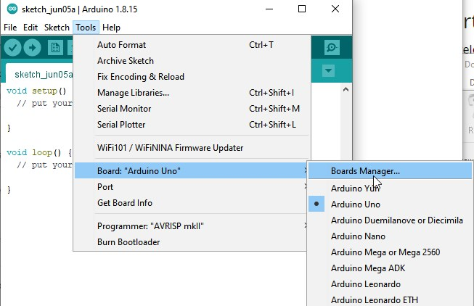

* Search **ESP8266** and install it.

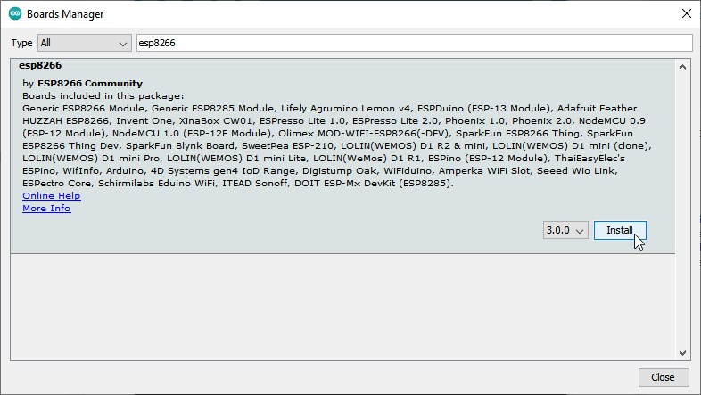

* Now go to “**Sketch**>**Include Library**” and click “**Manage libraries**.”

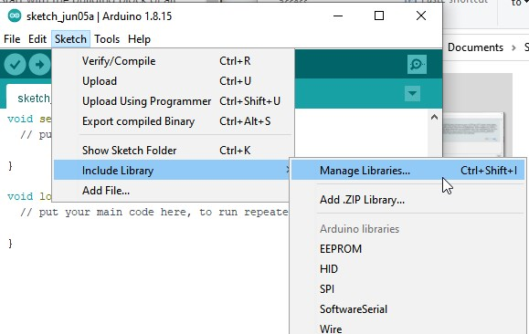

* Search and install “**IRremoteESP8266**” and install it.

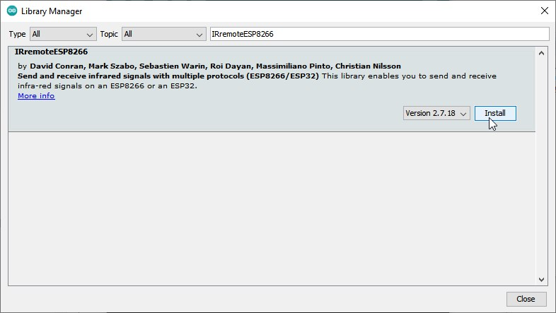

Finally, click “**Tools**>**Boards**” and select “**NodeMcu 1.0(ESP 12-E)”**from the available options.

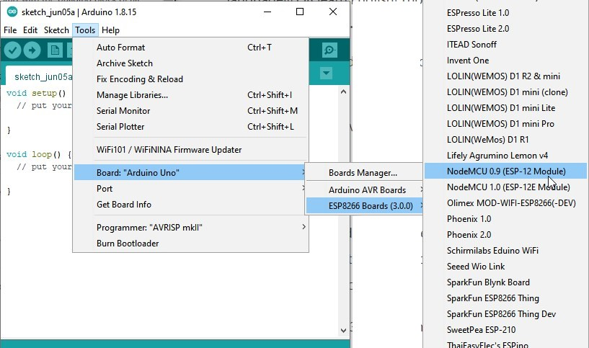

STEP 3: CAPTURE AND RECORD THE IR CODES

To capture codes, you need to first flash the following code using Arduino IDE.

* Restart Arduino IDE and then go to **File>Examples>IRRemoteESP8266** and select ‘**IRrecvDump2**.’

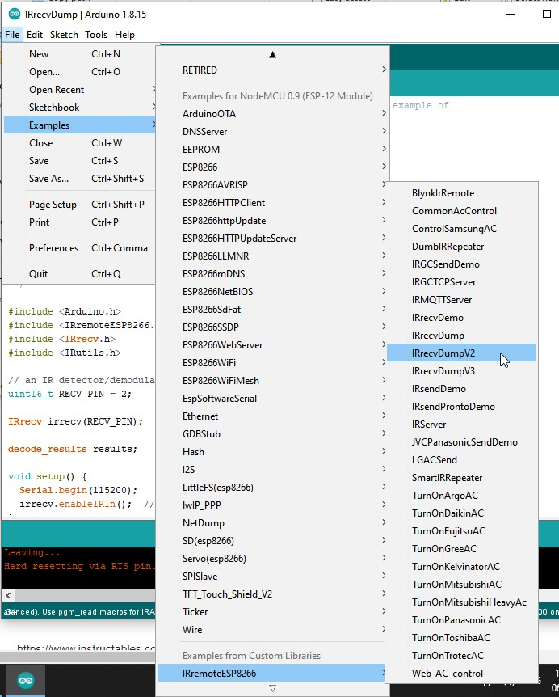

* Connect**ESP8266** to PC and go to **Tools>Port**and select the **COM** port.

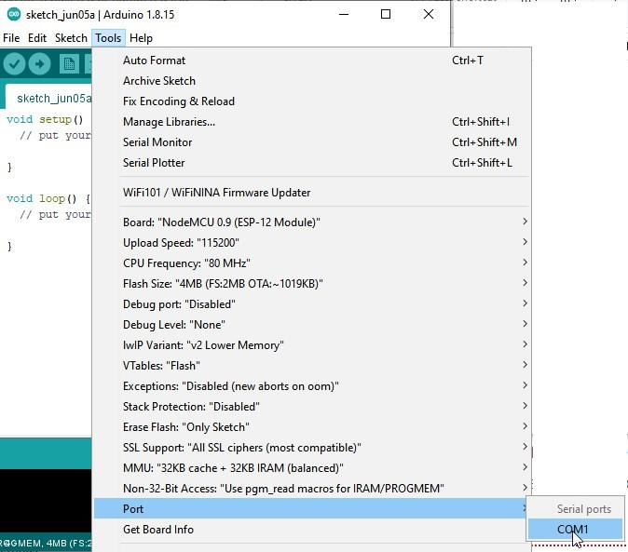

* Click ‘**Upload**‘ or press ‘**CTRL+U**‘ to flash the code.

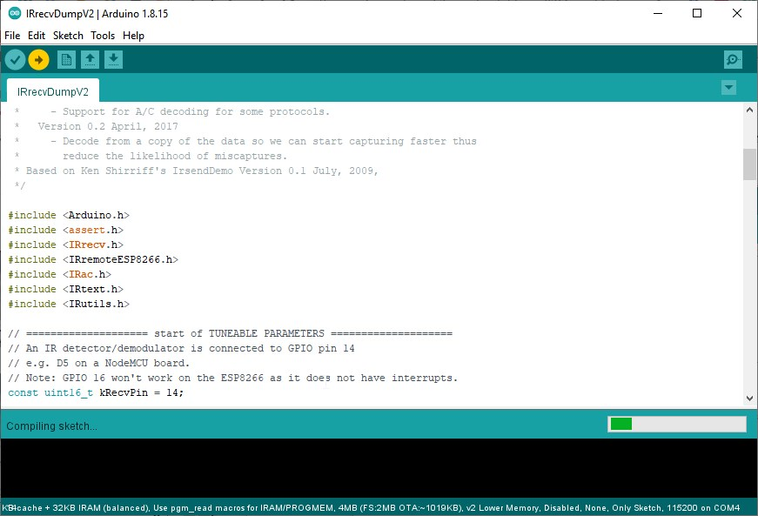

Then connect the IR Receiver sensor TSOP1738 to ESP8266. Refer to the following schematics diagram.

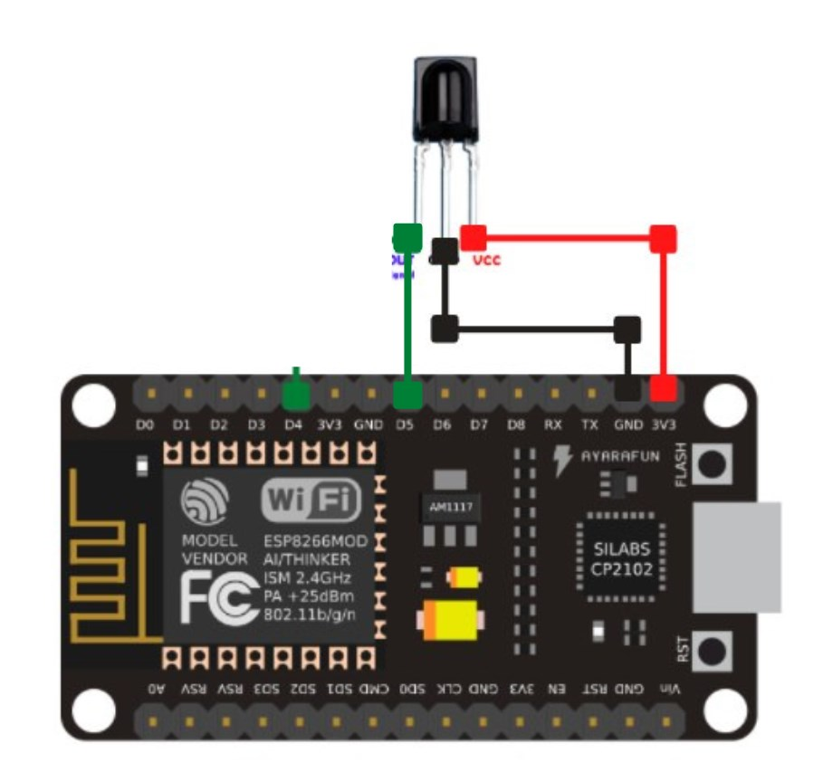

* Connect the the **OUT** pin to **D5** pin of ESP8266.

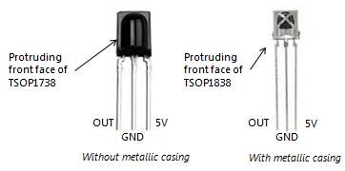

* Then connect the **GND** or middle pin of TSOP1738 to the **Ground** pin (marked as **G**) on ESP8266.
* Then connect the 5V pin of TSOp1738 to the 3V pin on ESP8266.
* Connect ESP8266 to PC again and click on the lens icon at the top right to open the serial monitor. Select 115200 baud rate from the drop-down.

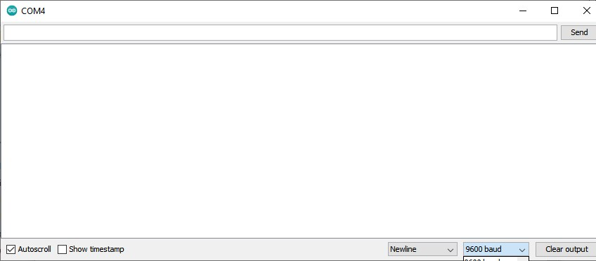

* Now get your IR remote, such as TV remote or Home Theatre remote controller, and press the button in front of the TSOP1738 IR receiver sensor.

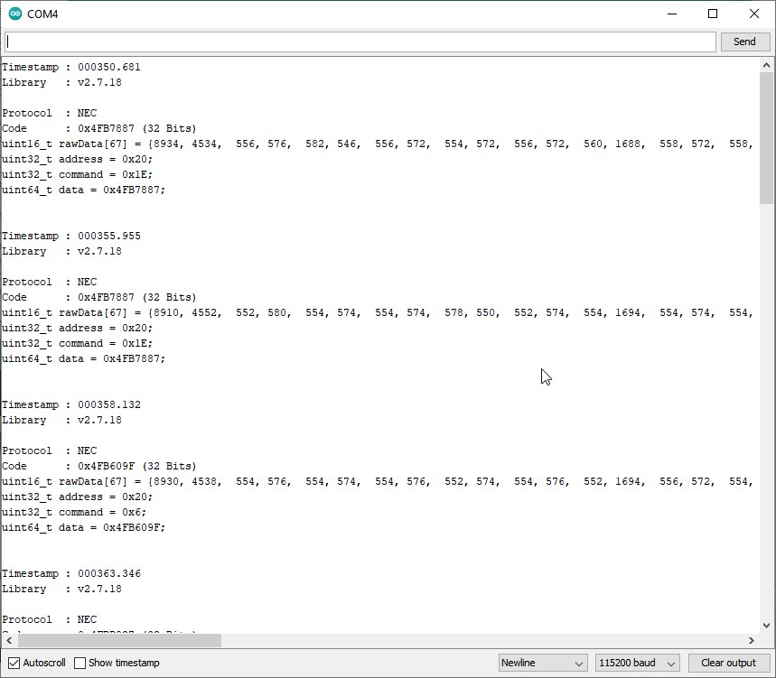

* The Serial Monitor will display the HEX code. You need to note down this hex code for each key like this in an Excel sheet.

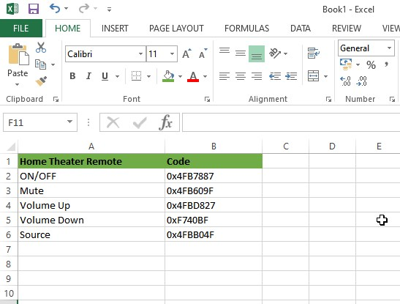

* Also, convert these HEX codes to Decimal using [HEXADECIMAL to DECIMAL Converter tool](https://www.rapidtables.com/convert/number/hex-to-decimal.html).

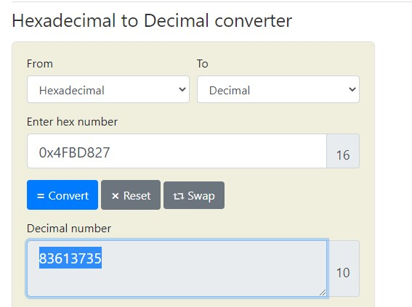

STEP 3: BUILD IR BLASTER

Once you have recorded all buttons and their HEX codes in an Excel workbook, it’s time to build the IR blaster to control all those devices. So disconnect the TSOP1738 and take out the 2N2222 or BC547 Transistor and the IR LED. Connect them as shown in the following diagram.

IR Blaster Circuit Diagram

Once connected, go to Arduino IDE and navigate to **File>Examples>IRremoteESP8266** and select I**RServer**.

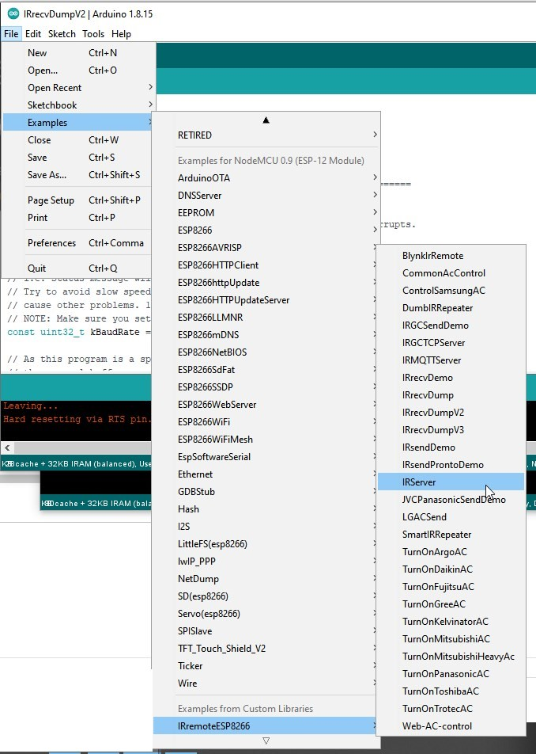

This opens a new **IRServer.ino** window. Scroll down a bit and add your WiFi SSID and Password. Replace the “……” with your WiFi SSID and Password as shown in the image.

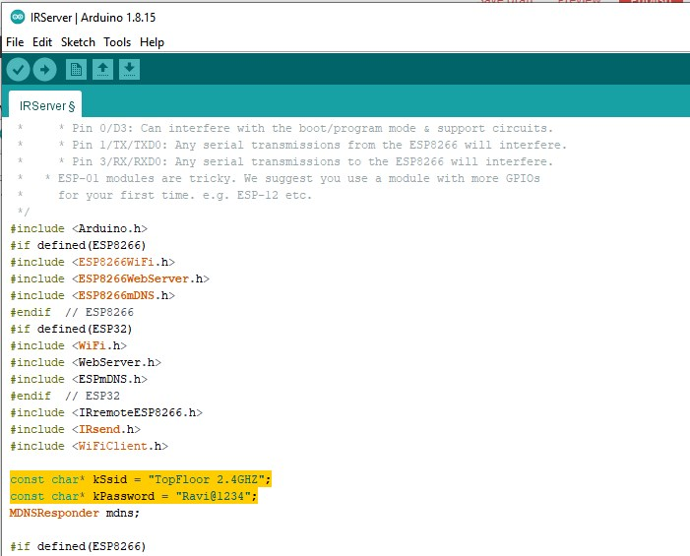

Scroll a bit more till you see the code as highlighted in following image.

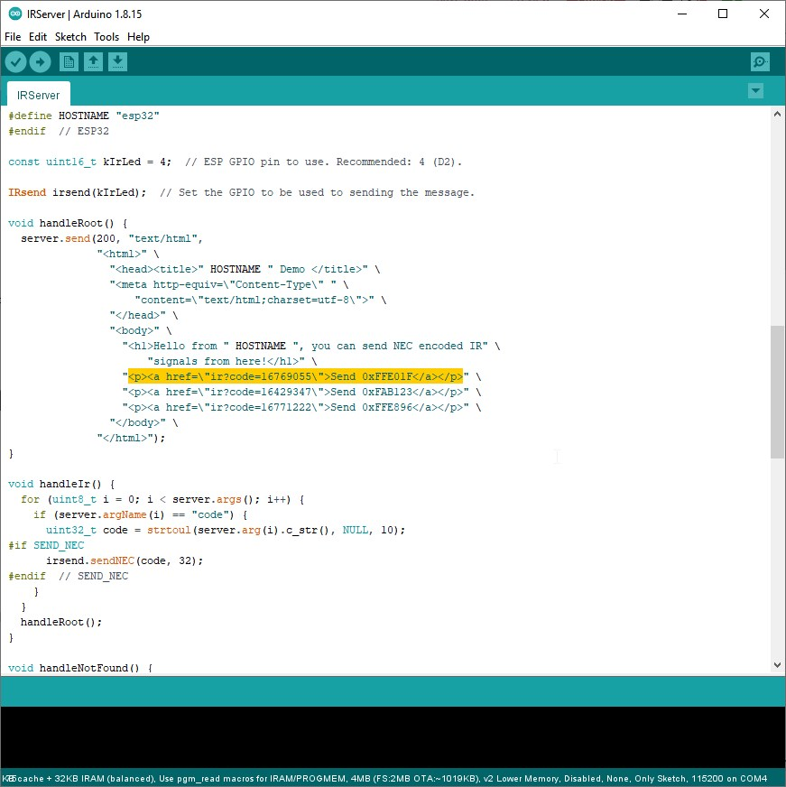

Now all you need to do is replace the “**ir?code=**” value to the converted decimal number (you converted earlier using HEX to Decimal Converter tool) of your remote controller button. You can also edit >**Send** **HexCode**</a> with remote button name, such as **ON/OFF**.

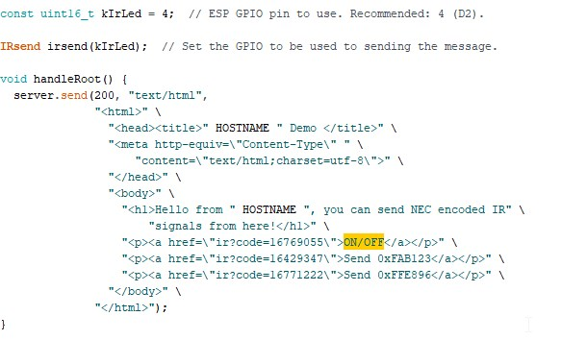

Similarly, you can add all your remote codes to the code. Just copy and paste following line of code below the exiting three to add more buttons.

"<p><a href=\"ir?code=16769055\">ON/OFF</a></p>" \

Once you have added all remote control codes (in decimal numbers), click ‘**Upload**‘ or press **CTRL+U** to upload the code. After this, you are ready to control all your devices with this DIY IR blaster. You may add more IR LED in circular pattern for better performance.

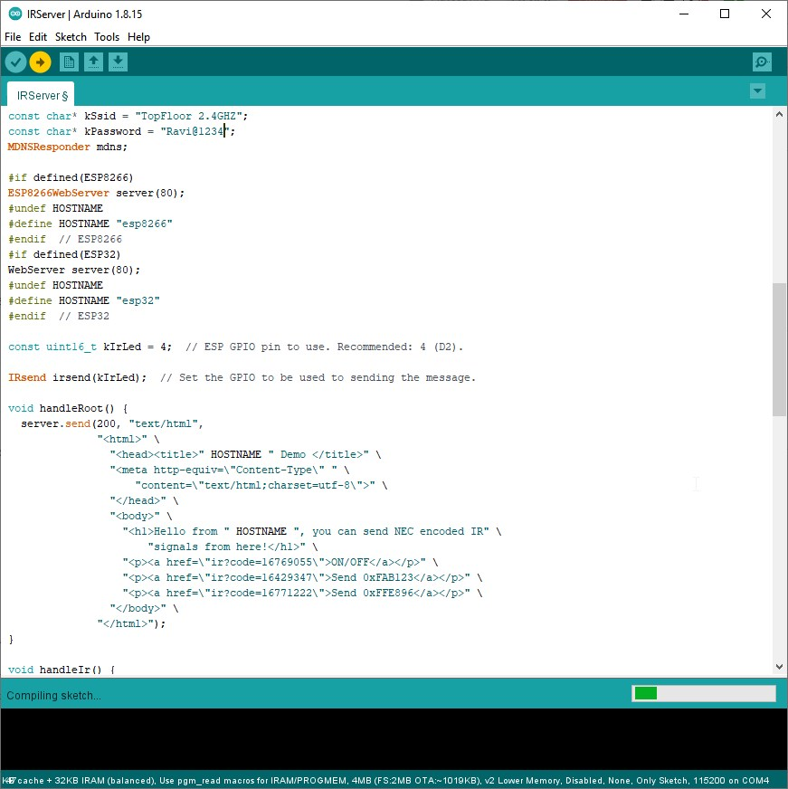

Open serial monitor to check the IP address.

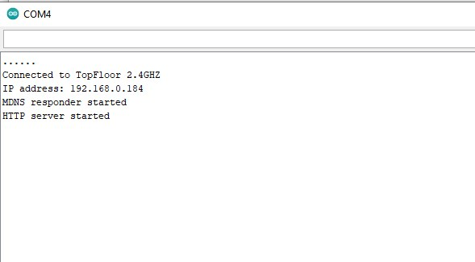

Then in your web browser (on PC or Phone), visit that IP address. You will see the linked buttons to control your IR devices.

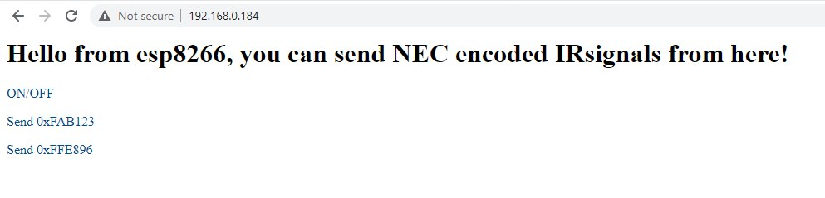

You may also use my **[IRServer.ino](https://drive.google.com/file/d/1xVGmQHfrn-v9Bg4iWeWEvmpeNXB6MA2l/view?usp=sharing" \t "_blank)**code and edit/change values to have customized controls.

/\*

\* IRremoteESP8266: IRServer - demonstrates sending IR codes controlled from a webserver

\* Version 0.3 May, 2019

\* Version 0.2 June, 2017

\* Copyright 2015 Mark Szabo

\* Copyright 2019 David Conran

\*

\* An IR LED circuit \*MUST\* be connected to the ESP on a pin

\* as specified by kIrLed below.

\*

\* TL;DR: The IR LED needs to be driven by a transistor for a good result.

\*

\* Suggested circuit:

\* https://github.com/crankyoldgit/IRremoteESP8266/wiki#ir-sending

\*

\* Common mistakes & tips:

\* \* Don't just connect the IR LED directly to the pin, it won't

\* have enough current to drive the IR LED effectively.

\* \* Make sure you have the IR LED polarity correct.

\* See: https://learn.sparkfun.com/tutorials/polarity/diode-and-led-polarity

\* \* Typical digital camera/phones can be used to see if the IR LED is flashed.

\* Replace the IR LED with a normal LED if you don't have a digital camera

\* when debugging.

\* \* Avoid using the following pins unless you really know what you are doing:

\* \* Pin 0/D3: Can interfere with the boot/program mode & support circuits.

\* \* Pin 1/TX/TXD0: Any serial transmissions from the ESP8266 will interfere.

\* \* Pin 3/RX/RXD0: Any serial transmissions to the ESP8266 will interfere.

\* \* ESP-01 modules are tricky. We suggest you use a module with more GPIOs

\* for your first time. e.g. ESP-12 etc.

\*/

#include <Arduino.h>

#if defined(ESP8266)

#include <ESP8266WiFi.h>

#include <ESP8266WebServer.h>

#include <ESP8266mDNS.h>

#endif // ESP8266

#if defined(ESP32)

#include <WiFi.h>

#include <WebServer.h>

#include <ESPmDNS.h>

#endif // ESP32

#include <IRremoteESP8266.h>

#include <IRsend.h>

#include <WiFiClient.h>

const char\* kSsid = "XXXXXXXXX";

const char\* kPassword = "XXXXXXXXX";

MDNSResponder mdns;

#if defined(ESP8266)

ESP8266WebServer server(80);

#undef HOSTNAME

#define HOSTNAME "TechPosts IR Server"

#endif // ESP8266

#if defined(ESP32)

WebServer server(80);

#undef HOSTNAME

#define HOSTNAME "esp32"

#endif // ESP32

const uint16\_t kIrLed = 4; // ESP GPIO pin to use. Recommended: 4 (D2).

IRsend irsend(kIrLed); // Set the GPIO to be used to sending the message.

void handleRoot() {

server.send(200, "text/html",

"<html>" \

"<head><title>" HOSTNAME " Demo </title>" \

"<meta http-equiv=\"Content-Type\" " \

"content=\"text/html;charset=utf-8\">" \

"</head>" \

"<body>" \

"<h1>Control All IR Devices with " HOSTNAME ".</h1>" \

"<h2>RGB Board</h2>" \

"<p><a href=\"ir?code=16236607\"> RGB ON</a></p>" \

"<p><a href=\"ir?code=16203967\"> OFF</a></p>" \

"<p><a href=\"ir?code=16246807\"> RANDOM</a></p>" \

"<p><a href=\"ir?code=16195807\"> RED</a></p>" \

"<p><a href=\"ir?code=16228447\"> GREEN</a></p>" \

"<p><a href=\"ir?code=16228447\"> BLUE</a></p>" \

"<p><a href=\"ir?code=16244767\"> WHITE</a></p>" \

"<p><a href=\"ir?code=16208047\"> BLUE 1</a></p>" \

"<p><a href=\"ir?code=16216207\"> BLUE 2</a></p>" \

"<p><a href=\"ir?code=16206007\"> BLUE 3</a></p>" \

"<p><a href=\"ir?code=16214167\"> BLUE 4</a></p>" \

"<p><a href=\"ir?code=16224367\"> GREEN 1</a></p>" \

"<p><a href=\"ir?code=16232527\"> GREEN 1</a></p>" \

"<p><a href=\"ir?code=16222327\"> GREEN 1</a></p>" \

"<p><a href=\"ir?code=16230487\"> GREEN 1</a></p>" \

"<p><a href=\"ir?code=16191727\"> RED 1</a></p>" \

"<p><a href=\"ir?code=16199887\"> RED 1</a></p>" \

"<p><a href=\"ir?code=16189687\"> RED 1</a></p>" \

"<p><a href=\"ir?code=16197847\"> RED 1</a></p>" \

"<h2>Creative Stage Controls</h2>" \

"<p><a href=\"ir?code=83595375\"> Stage ON/OFF</a></p>" \

"<p><a href=\"ir?code=83603535\"> INPUT</a></p>" \

"<p><a href=\"ir?code=83593335\"> RESET</a></p>" \

"<p><a href=\"ir?code=83591295\"> BT-PAIR</a></p>" \

"<h3>Equalizers</h3>" \

"<p><a href=\"ir?code=83605575\"> CINEMA</a></p>" \

"<p><a href=\"ir?code=83597415\"> MUSIC</a></p>" \

"<p><a href=\"ir?code=83601495\"> CONCERT</a></p>" \

"<p><a href=\"ir?code=83577015\"> GAMING</a></p>" \

"<h3>Bluetooth Controls</h3>" \

"<p><a href=\"ir?code=83621895\"> STOP</a></p>" \

"<p><a href=\"ir?code=83613735\"> PLAY/PAUSE</a></p>" \

"<p><a href=\"ir?code=83617815\"> NEXT</a></p>" \

"<p><a href=\"ir?code=83619855\"> PREVIOUS</a></p>" \

"<h3>Treble</h3>" \

"<p><a href=\"ir?code=83558655\"> INCREASE</a></p>" \

"<p><a href=\"ir?code=83607615\"> DECREASE</a></p>" \

"<h3>Bass</h3>"

"<p><a href=\"ir?code=83587215\"> INCREASE</a></p>" \

"<p><a href=\"ir?code=83581095\"> DECREASE</a></p>" \

"<h3>Volume</h3>" \

"<p><a href=\"ir?code=83583135\"> INCREASE</a></p>" \

"<p><a href=\"ir?code=83615775\"> DECREASE</a></p>" \

"<p><a href=\"ir?code=83589255\"> MUTE</a></p>" \

"</body>" \

"</html>");

}

void handleIr() {

for (uint8\_t i = 0; i < server.args(); i++) {

if (server.argName(i) == "code") {

uint32\_t code = strtoul(server.arg(i).c\_str(), NULL, 10);

#if SEND\_NEC

irsend.sendNEC(code, 32);

#endif // SEND\_NEC

}

}

handleRoot();

}

void handleNotFound() {

String message = "File Not Found\n\n";

message += "URI: ";

message += server.uri();

message += "\nMethod: ";

message += (server.method() == HTTP\_GET)?"GET":"POST";

message += "\nArguments: ";

message += server.args();

message += "\n";

for (uint8\_t i = 0; i < server.args(); i++)

message += " " + server.argName(i) + ": " + server.arg(i) + "\n";

server.send(404, "text/plain", message);

}

void setup(void) {

irsend.begin();

Serial.begin(115200);

WiFi.begin(kSsid, kPassword);

Serial.println("");

// Wait for connection

while (WiFi.status() != WL\_CONNECTED) {

delay(500);

Serial.print(".");

}

Serial.println("");

Serial.print("Connected to ");

Serial.println(kSsid);

Serial.print("IP address: ");

Serial.println(WiFi.localIP().toString());

#if defined(ESP8266)

if (mdns.begin(HOSTNAME, WiFi.localIP())) {

#else // ESP8266

if (mdns.begin(HOSTNAME)) {

#endif // ESP8266

Serial.println("MDNS responder started");

}

server.on("/", handleRoot);

server.on("/ir", handleIr);

server.on("/inline", [](){

server.send(200, "text/plain", "this works as well");

});

server.onNotFound(handleNotFound);

server.begin();

Serial.println("HTTP server started");

}

void loop(void) {

server.handleClient();

}

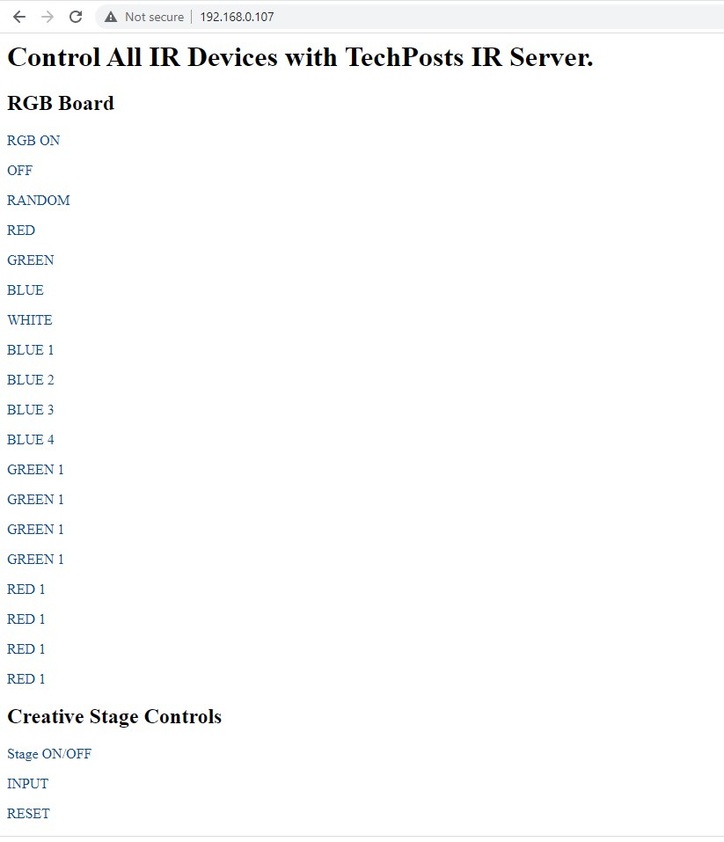

Now let’s setup buttons on Android phone to control devices.